**Practical No.08**

**Aim: Programs based on Pointer.**

**1. C Program to illustrate use of Pointer in Arithmetic Operation.**

**Program:**

#include<stdio.h>

#include<conio.h>

void main()

{

int a,b,*p1,*p2,x,y,z;

clrscr();

a=12;

b=4;

p1=&a;

p2=&b;

x=*p1**p2-6;

y=4*-*p2 / *p1+10;

printf("Address of a=%u \n",p1);

printf("Address of b=%u \n",p2);

printf("\n");

printf("a=%d,b=%d\n",a,b);

printf("x=%d,y=%d\n",x,y);

getch();

}

**Output:**

Address of a=65524

Address of b=65522

a=12,b=4

x=42,y=9

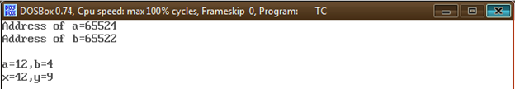

**2. C Program to Compute Sum of all Elements in Array**

**Program:**

#include<stdio.h>

#include<conio.h>

void main()

{

int *p,sum,i;

int x[5]={5,9,6,3,7};

clrscr();

i=0;

p=x;

printf("Element value address \n");

while(i<5)

{

printf("x[%d] %d %u \n",i,*p,p);

sum=sum+*p; //Accessing array element

i++;

p++;

}

printf("\n sum=%d \n",sum);

printf("\n &x[0]=%u \n",&x[0]);

printf("\n p=%u \n",p);

getch();

}

**Output:**

Element value address

x[0] 5 65514

x[1] 9 65516

x[2] 6 65518

x[3] 3 65520

x[4] 7 65522

sum=-28724

&x[0]=65514

P=65524

